ፕላያብል (PLIABLE) ምስ ኪንግ ካውንቲ ብምትሕብባር
ቆልዑ ኮምዩኒቲ ጥራይ

ክሊኒክ ክታበት COVID-19

(ካብ 5 ክሳብ ትሕቲ 12)
በጃኹም ን ክልቲኡ 1ይን 2ይን ዓቐን (ዶዝ) ተመዝገቡ

1ይ ዓቐን (ዶዝ)
ሕዳር 28, 2021
8:30 AM ክሳብ 04:30 PM
ኣድራሻ፡Neighborhood House High Point 6400 Sylvan Way SW I Seattle WA I 98126
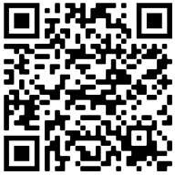

https://prepmod.doh.wa.gov//appointment/en/reg/0034621909

2ይ ዓቐን (ዶዝ)
ታሕሳስ 19, 2021
8:30 AM ክሳብ 04:30 PM
ኣድራሻ፡Neighborhood House High Point 6400 Sylvan Way SW I Seattle WA I 98126
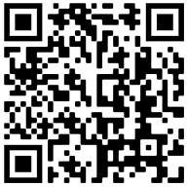

https://prepmod.doh.wa.gov//appointment/en/reg/0361409392

ብቆጸራ ጥራይ
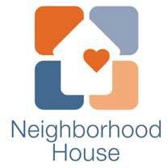
iob e
;
mindfully driven healthcare

