LA SHAQEYN-OG ISKAASHATADA KING COUNTY
Bulshada Caruurta Keliya

GOOBTA TALLAALKA COVID-19

(da'da 5 ilaa 12)
Fadlan isku qor LABADA irbadba 1'aad iyo 2'aadba

IRBADDA 1'aad
Nofeembar 28, 2021
8:30AM ilaa 04:30PM
Neighborhood House High Point
6400 Sylvan Way SW I Seattle WA I 9 8126

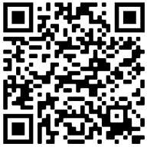

https://prepmod.doh.wa.gov//appointment/en/reg/0034621909

IRBADDA 2'aad
Diseembar 19, 2021
8:30AM ilaa 04:30PM
Neighborhood House High Point
6400 Sylvan Way SW I Seattle WA I 9 8126

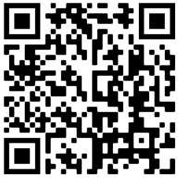

https://prepmod.doh.wa.gov//appointment/en/reg/0361409392

BALLAN KELIYA ku qaabila
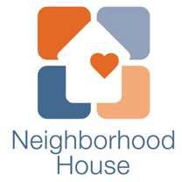
iobe
;
mindfullydrivenhealthcare

