PLIABLE IN PARTNERSHIP WITH KING COUNTY
community pediatric-only

COVID-19 VACCINE CLINIC

(5 to under 12)
Please sign up for BOTH 1st and 2nd doses

DOSE 1
November 28, 2021
8:30 AM to 04:30 PM
Neighborhood House High Point 6400 Sylvan Way SW I Seattle WA I 98126

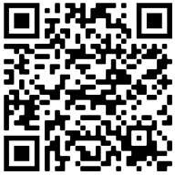

https://prepmod.doh.wa.gov//appointment/en/reg/0034621909

DOSE 2
December 19, 2021
8:30 AM to 04:30 PM
Neighborhood House High Point 6400 Sylvan Way SW I Seattle WA I 98126

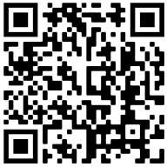

https://prepmod.doh.wa.gov//appointment/en/reg/0361409392

BY APPOINTMENT ONLY

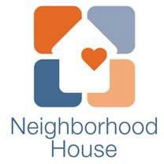
iob e
;
mindfully driven healthcare

