**Date:** February 14, 2020

**To:** Seattle CityCouncilmembers, Transportation and Utilities Committee

**Cc:** Shefali Ranganathan, Deputy Mayor

**From:** Sam Zimbabwe, SDOT Director

**Prepared by:** CJ Holt, Project Manager and Lorelei Williams, Deputy Director of Capital Projects

**Subject:** Response to Ordinance 125902 re: Delridge Way SW – RapidRide H Line

**Overview**

In September 2019, the Seattle City Council passed [Ordinance 125902](http://clerk.seattle.gov/search/ordinances/125902) to require that “whenever SDOT constructs a major paving project along a segment of the protected bicycle lane network, a protected bicycle lane with adequate directionality shall be installed along that segment.” If the Director determines that “the characteristics of the physical features or usage of a street, or financial constraints of full compliance prevent the incorporation of a protected bicycle lane,” the Director shall provide a written report to Council detailing the following information:

1. Why it is impractical for this project to comply with subsection 15.80.020;
2. That the alternatives analyzed in determining that full compliance with subsection 15.80.020.A

are not practical; and

1. How connectivity of the protected bicycle lane network could be advanced in the absence of a

protected bicycle lane including a cost estimate for providing such connectivity.

The Seattle Department of Transportation (SDOT) has determined that meeting the conditions set forth in the ordinance are not practical for Delridge Way SW RapidRide H Line because, as stated in Section 1(B) of the ordinance, the “physical features or usage of [the] street… prevent[s] the incorporation of a protected bicycle lane with adequate directionality.”  This report to Council in accordance with Section 1(C) outlines the technical constraints that influenced the decision-making process, the alternatives considered in determining full compliance is not practical, and how connectivity of the bicycle network is advanced through the project.

The final design for the project includes the upgrades to existing neighborhood greenway routes, including installation of a southbound protected bicycle lane on Delridge Way SW from SW Juneau St to SW Cambridge St.

**Existing Conditions**

Delridge Way SW is currently served by Metro’s Route 120 and is identified as one of seven routes in Seattle’s RapidRide Expansion network. In 2021, Route 120 will become RapidRide H Line. The route 120 is one of the Metro’s 10 busiest routes countywide. Funding was provided in the Levy to Move Seattle to convert Route 120 into the RapidRide H Line and keep people moving by:

* Keeping buses frequent and on-time (frequency expected to improve to 10-minutes or better

all-day, with peak frequencies even higher)

* Adding more buses at night and on weekends for people who commute during off-peak hours or

use the bus for shopping, accessing community destinations, and other services

* Upgrading RapidRide bus stops with lighting, real-time arrival info, and more
* Improving sidewalks for people walking and bicycle infrastructure for people riding bicycles
* Improving pavement conditions

The purpose of the Delridge Way SW RapidRide H Line project is to improve the overall safety and multimodal features of the corridor while expanding the City’s RapidRide network. The project extends from the West Seattle Bridge to SW Cambridge St (approximately 4 miles) (for existing conditions cross sections see figure 1). Existing bicycle facilities for part of the corridor include:

* Protected bicycle lanes from SW Holden St to SW Myrtle St on both sides of

Delridge Way SW (approx. 0.4 miles)

* Striped bicycle lanes from SW Holden St to SW Kenyon St (approx. 0.1 miles)
* Sharrows from SW Kenyon St to SW Roxbury St (approx. 1 mile)
* Two neighborhood greenways that run the full length, parallel to the corridor. The Delridge Neighborhood Greenway on 26th Ave SW runs from SW Andover St to SW Graham St to the west of Delridge Way SW (approx. 1.6 miles). The Delridge-Highland Park Greenway runs along 17th Ave SW and 21st Ave SW from the West Seattle Bridge to SW Cambridge St to the east of Delridge Way SW (approx. 4 miles).

**Transit Master Plan Context**

King County Metro conducted a conceptual improvements study in 2011 for the Route 120 corridor responding to speed and reliability issues experienced between the West Seattle Bridge and Burien Transit Center. Capital improvements proposed for the Seattle segments of the Route 120 corridor which would be partially funded by King County included transit lanes, queue jumps, stop relocation/consolidation, channelization improvements, bus bulbs, traffic signal optimization and transit signal priority. Recommended improvements were selected based on impacts to transit reliability and travel time savings.

In 2012, City Council adopted its Transit Master Plan (TMP), establishing transit capital improvement priorities for high capacity transit and priority bus corridors. Delridge Way SW was evaluated as a priority bus corridor.  The TMP proposed a variety of improvements including transit signal priority at nearly all signalized intersections, bus bulbs throughout the corridor, and a business access and transit (BAT) lane on the north portion of the corridor. The BAT lanes were implemented in 2012.

City Council adopted an amended TMP in 2016, elevating Delridge Way SW to a future RapidRide corridor with full RapidRide branding at 24 high-amenity stations. RapidRide H will provide a frequent transit connection between the Burien Transit Center, the Westwood Shopping Center (with connections to the C Line), and South Lake Union (via the 3rd Ave Transit Spine). The Amended TMP proposed transit priority treatments at all signalized intersections and increased stop spacing to improve speed and reliability. Roughly 30% of the 10.1-mile alignment would be furnished with 24-hour dedicated transit lanes, as well as 24-hour bi-directional BAT lanes on Delridge Way SW between SW Andover and SW Alaska streets. RapidRide and its enhanced service, vehicles, and passenger amenities were intended to prioritize transit movement and redefine the passenger experience for new and existing riders.

**Bicycle Master Plan Context**

In 2014, the City Council approved the Bicycle Master Plan (BMP), which provided the framework for bicycle investments throughout the City. The BMP recommended a two-way protected bicycle lane on Delridge Way SW from the West Seattle Bridge to Orchard Way SW for approximately 2.5 miles (see figure 2). This recommendation overlapped with about half of the corridor identified in the TMP between the West Seattle Bridge and SW Orchard St.

The following are references in the BMP that provide guidance moving forward with implementation of bicycle connectivity if the recommendations in the BMP were not practical:

* **P.52** - Strategy 4.2.2 - Discusses the process for using a parallel greenway to provide bicycle connections if unable to move forward with a cycle track or protected bicycle lane. According to the BMP “If through the process SDOT determines that a proposed cycle track is not feasible, implement a neighborhood greenway on a parallel street to provide an all ages and abilities bicycle connection to destinations”.
* **P. 70 -** Under Multimodal Corridors the BMP provides context on treating bike facilities when implementing multimodal corridors. According to the BMP: “while all efforts will be made to implement the recommended bicycle network on the multimodal corridors, people riding bicycles can more easily be accommodated on parallel non-arterial streets than other modes.”
* **P. 95 -** Strategy 7.1.1 - Discusses the project delivery process and what to do if a protected bicycle lane is not practical. The strategy states that through public engagement, data collection and technical analysis SDOT can develop concept design alternatives. Once there is a preferred design: “if it has been determined that a recommended cycle track (protected bicycle lane) is not feasible on the arterial street, then the project team would incorporate an adjacent neighborhood greenway to ensure people of all ages and abilities can ride to their destinations on all ages and abilities bicycle facility”.

SDOT considered these strategies throughout the planning and design phase of the Delridge Way SW RapidRide H Line project.

**Design Alternatives Considered**

Given that both the TMP and the BMP identified the Delridge corridor as priority corridors for plan implementation, the project team worked to identify ways to provide frequent and reliable transit service along the corridor, while providing connectivity to the bicycle network. In 2016, SDOT developed five concept options which balanced modal priorities. Based on internal evaluation, two options were selected to move forward into project definition which would implement corridor bicycle facilities using different approaches (see figures 3 and 4).

SDOT recognized early on that the design would include trade-offs between the travel modes due to the physical limitations and usage of the street. Adding bus lanes separate from the general travel lanes to keep the most people moving made it technically infeasible to add new protected bicycle lanes both northbound and southbound for the full length of the project area because of width constraints.

SDOT reached out to the surrounding community during the initial planning phase to learn what improvements they would like along the Delridge corridor. Community feedback included:

* Support for prioritizing buses on Delridge Way SW
* Interest in a safer and connected bicycle route through the Delridge corridor, but a lack of consensus on the preferred route
* Acknowledgment of Route 120 as an important neighborhood connector, not just as a way to

get people to and from downtown Seattle

* Desire to keep and improve bus access for the most vulnerable people in the community
* Desire to see Delridge Way SW repaved and restored to a smoother surface

Regarding bicycle lanes, responses were split on whether bicycle lanes should be on or off of Delridge Way SW. Face-to-face outreach as well as survey responses indicated that respondents desired better connectivity between existing neighborhood greenways and Delridge Way SW, and if adding a bicycle lane to Delridge Way SW, it should span the full length, especially in areas where the greenways have a steep grade (particularly between Delridge Way SW and 21st Ave SW on Croft Pl SW).  It should be noted that the 2014 BMP recommendation only recommended protected bicycle lanes between West Seattle Bridge and SW Orchard St, not the full length of Delridge Way SW (see figure 2 showing the recommended BMP facility).

In parallel with broader community engagement on the project, SDOT also worked closely with the bicycle community and transit advocates in 2017 and 2018 to develop a project that would address the transit and bicycle goals in the corridor. SDOT had several meetings with West Seattle Bicycle Connections, Transportation Choices Coalition, Cascade Bicycle Club and Seattle Neighborhood Greenways.

After much discussion, these organizations conditionally supported a design that would include the southbound protected bicycle lane in the southern section of Delridge with requests to start the southbound lane at SW Juneau St (not SW Graham St as initially proposed) to connect to the existing neighborhood greenway and to make improvements to the existing parallel neighborhood greenways.  A letter dated April 11, 2018 outlined the support of advocates that participated in this process (see attached letter).

Based on the additional work with community groups and bicycle advocates, SDOT developed an Option 3 (Preferred Alternative) which combines elements from the original two options and includes both on- and off-Delridge Way SW bicycle facilities offering both northbound and southbound bicycle facilities between hubs. This option was adopted as the preferred alternative that SDOT carried into design development.  See below figures and table for details on the preferred alternative.

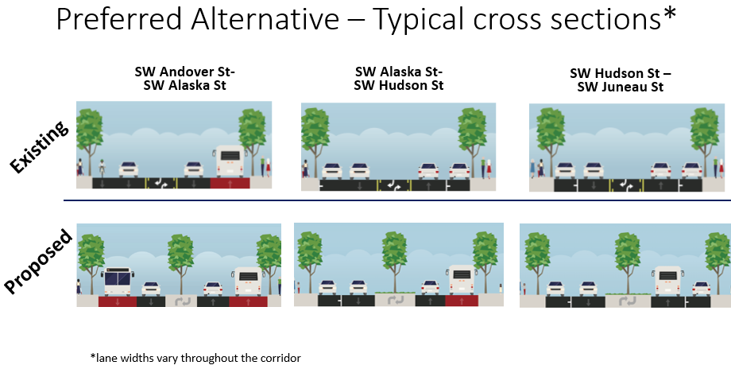

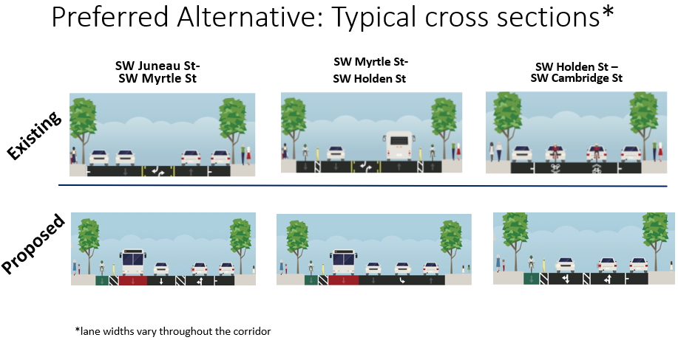

|  |  |  |  |
| --- | --- | --- | --- |
|  | **OPTION 1** | **OPTION 2** | **OPTION 3 (PREFERRED ALTERNATIVE)** |
| New Greenway Connections | 6 | 6 | 7 |
| Improved Pedestrian Crossings | 4 | 4 | 4 |
| New ADA Ramps (intersections) | 17 | 17 | 25 |
| Bus Only Lanes | 1.4 miles (all day) + 1.2 miles (peak hours only) | 1.4 miles (all day) | 1.4 miles (all day) + 1.2 miles (peak hours only) |
| Protected Bicycle Lane | .3 miles | 2.9 miles | 2.1 miles |
| Widened Mix-Use Sidewalk | .9 miles | 0 miles | 0 miles |
| Landscaped Median | 2.5 miles | 1.8 miles | 1.9 miles |
| Bus Travel Time (Range for north and southbound) | Up to 9-16% faster | Up to 8-12% faster | 5% faster NB and 13% faster SB |
| Traffic Travel Time | Up to 1.8% faster | Up to 5-10% slower | 5% slower NB and 8% faster SB |
| On-Street Parking | Some all-day parking converted to off-peak parking and new off-peak parking added | Up to 73% of parking retained as a mix of all-day and off-peak | Up to 71% of parking retained as a mix of all-day and off-peak |
| Loading Zones | No loading zones removed | Small number of loading zones relocated | Small number of loading zones relocated |
| Street Trees | Up to 80% of street trees retained | Up to 100% of street trees retained | 99% of street trees retained |

The following summarizes the design process, changes and general implications of implementing a standard 8’ protected bicycle lane per the BMP recommendation by section as shown in the typical cross sections which show the proposed design compared to the proposed design with a BMP proposed protected bicycle lane:

* SW Andover St – SW Alaska St (approx. 0.5 miles): This cross section would require elimination of the planned bus lanes on both sides of the street to incorporate a standard two-way protected bicycle lane
* SW Alaska St – SW Hudson St (approx. 0.3 miles): This cross section would require elimination of the planned bus lane on one side of the street and existing on-street parking to incorporate a standard two-way protected bicycle lane
* SW Hudson St – SW Juneau St (approx. 0.5 miles): This cross section would require removal of existing on-street parking on both sides of the street to incorporate a standard two-way protected bicycle lane
* SW Juneau St – SW Myrtle St (approx. 0.8 miles): This cross section would require removal of existing parking on one side of the street to incorporate a standard northbound protected bicycle lane (southbound protected bicycle lane is already planned for and parking for that side is being removed). Also note that there is parking in this location that is dedicated for school bus pick-up and drop-off for the Louisa Boren Stem K-8 School which was retained as part of community outreach with the school
* SW Myrtle St – SW Holden St (approx. 0.4 miles): This cross section would require removal of a future southbound bus lane to incorporate a standard northbound protected bicycle lane (southbound protected bicycle lane is already planned for).

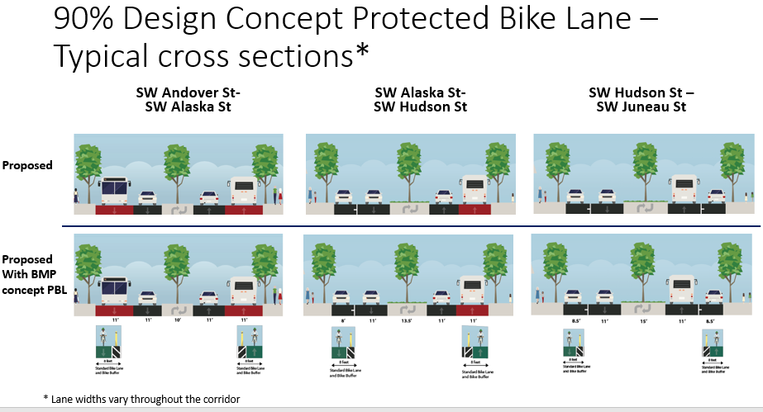

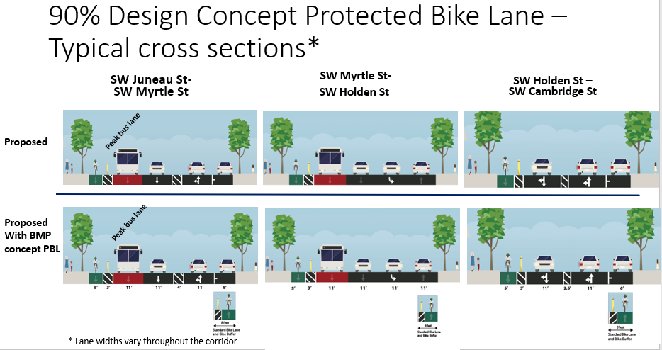

Due to varying lane widths throughout the corridor, a continuous protected north and south bicycle lane as called for in the BMP is not possible without impacting bus lanes which will improve transit an estimated 7,100 daily riders; SDOT has chosen to prioritize the bus lanes over a two-way protected bicycle lane facility on Delridge. It could be provided in some sections of the corridor by removing parking, however, the start and stop of the facility is not ideal, which is why the current approach was chosen.

**Final Design**

Based on the preferred alternative, SDOT has been advancing design since 2017 and is currently nearing final design. If the design was updated to include standard protected bicycle lanes on Delridge Way SW from SW Andover St to Sylvan Way SW per the BMP recommendation, the change would negatively impact transit speed and reliability which is a primary goal for the project. This would occur at the north end between SW Andover St and SW Alaska St and in the south between SW Myrtle St and SW Sylvan St where bus only lanes would need to be removed because of lane width constraints in this area. In additional areas, parking would need to be removed due to similar lane width restrictions.

The final design for the project includes the upgrades to existing greenway routes with Option 3, including installation of a southbound protected bicycle lane on Delridge Way SW from SW Juneau St to SW Cambridge St.

In summary, The Delridge Way SW RapidRide H Line project is expected to be constructed by the end of 2021 and will include:

* **New dedicated Bus Lanes-** Bus-only lanes and queue jumps separate buses from traffic, increasing speed and reliability
* **New enhanced Bus Stops**- RapidRide stations include real-time arrival information, larger shelters, lighting, and other amenities
* **New off-Board Fare Collection**- Off-board fare collection helps buses move faster as riders can pay fares without waiting in line
* **Providing specialized Buses**- RapidRide buses offer lower floors for easier loading and unloading
* **New Smart Signals on Delridge Way SW** - Transit signal priority extends or activities green lights to reduce waiting times for buses at signals
* **Improved Bike and Pedestrian Connections**- Improvements to crossings, neighborhood greenways, and bicycle lanes will help people access new RapidRide lines and improve safety along the corridor
* **Increased ridership from 5,200 daily boardings today to a predicted +7,100 new daily boardings by (2035)**
* **187k jobs served and 49k residence served by 2035**
* **An anticipated outcome of up to 10-15% time travel savings on the new RapidRide H Line**
* **Street Improvements on Delridge Way SW such as:**
* New planted medians to green Delridge and calm traffic
* New art sculptures for community placemaking
* New paving for a smoother ride and long-lasting street
* New sewer and water pipes for drinking water and wastewater
* Increasing bus service on nights and weekends
* Consolidates, or removes 9 bus stops, RapidRide stations are now about 1/3 mile apart rather than 1/2

Figure : Existing Conditions (see attached for full sized PDF)

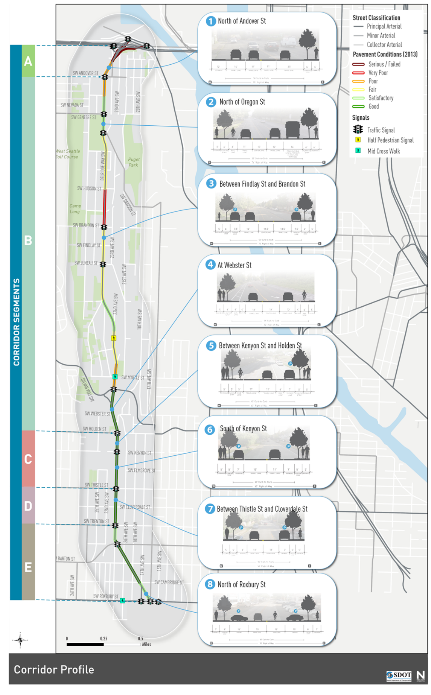

Figure : BMP Recommendation for Delridge Way SW (see attached for full sized PDF)

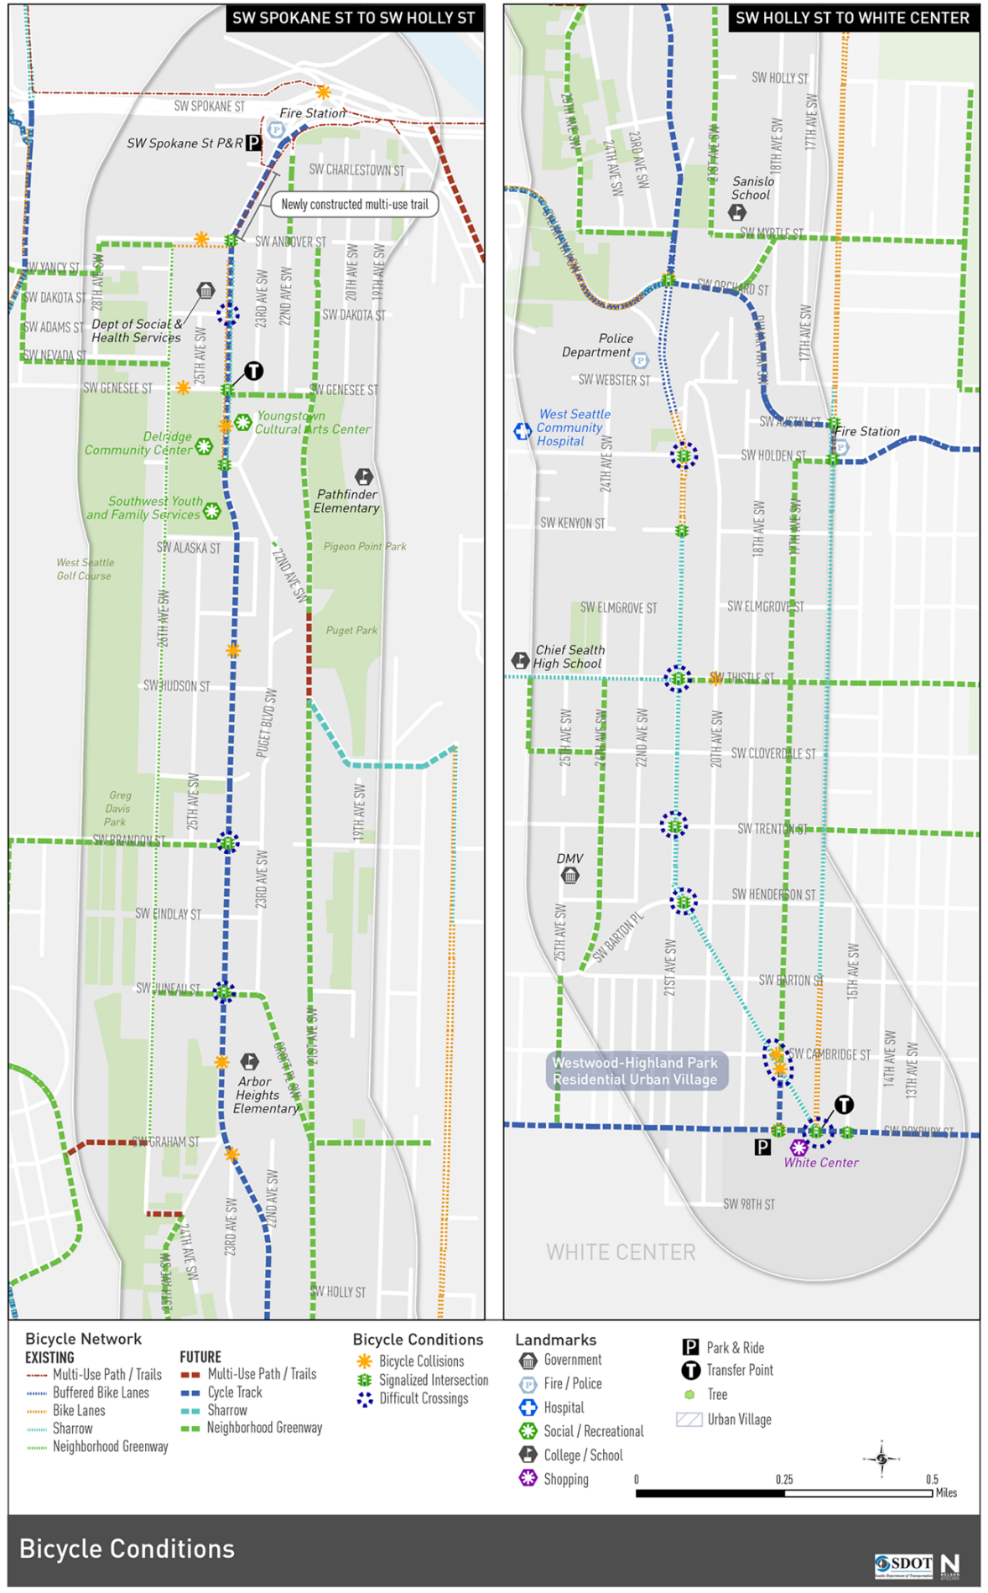

Figure : Concept Option 1 (see attached for full sized PDF)

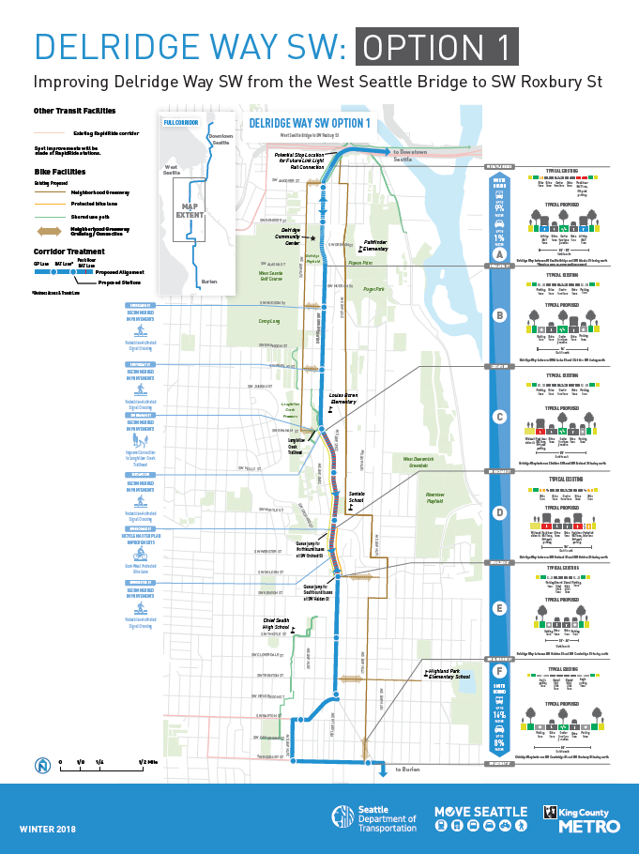

Figure : Concept Option 2 (see attached for full sized PDF)

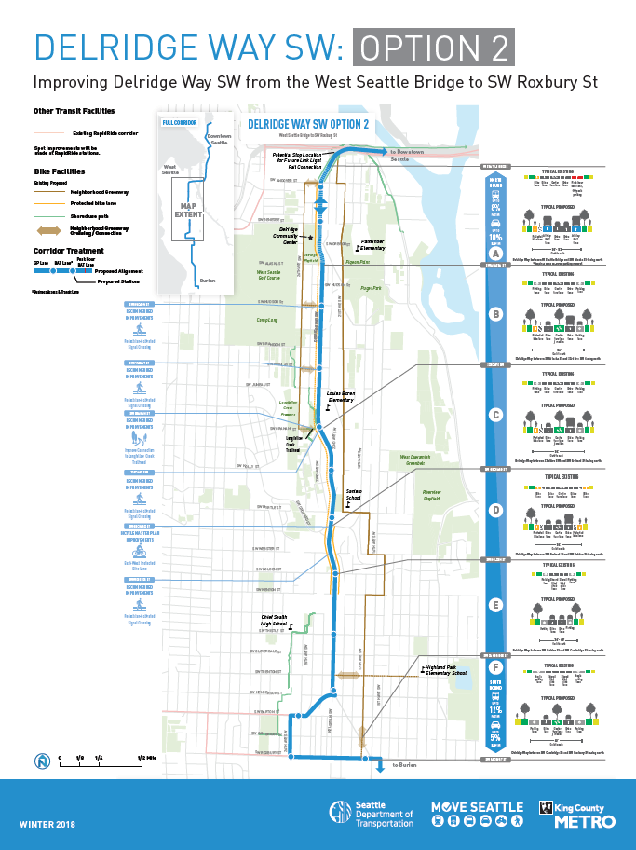

Figure : Option 3 (see attached for full sized PDF)

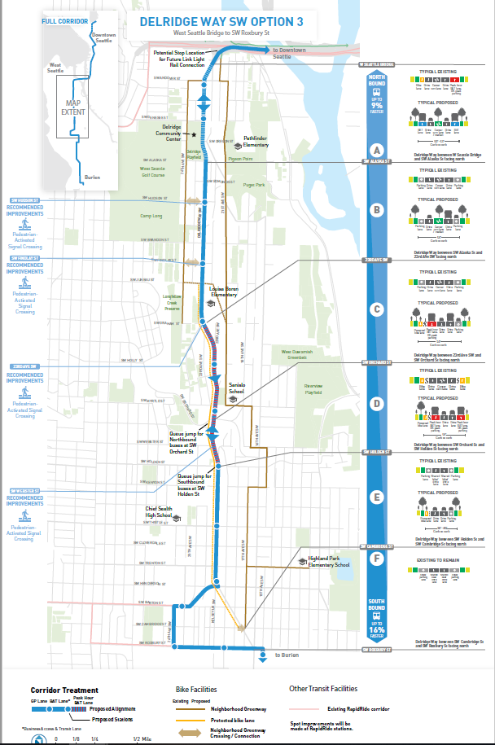

Figure : Bicycle Master Plan Delridge Recommendation

**Additional Information:**

* Complete Streets Checklist (attached)
* Letter of support of the preferred alternative from community advocates (attached)
* Full sized PDF of the Delridge Way SW Existing Conditions cross sections (attached)
* Full sized PDF of the Delridge Way SW BMP Recommendation (attached)
* Full sized PDF of the Delridge Way SW concept alternatives 1, 2 and 3 (attached)
* Planning outreach summary (attached)